Evaluating Digital Content Assignment Instructions
Overview
Open Educational Resources (OERs) continue to increase in popularity in higher education (Moore & Diehl, 2018). Nilson & Goodson (2018) state that using OERs within online courses improves learning. With this increase of popularity there is a vast amount of OERs (Moore & Diehl, 2018), but not all OERs are effective. It is critical educators understand how to evaluate the effectiveness of OERs (Moore & Diehl, 2018). In addition, Massive Open Online Course (MOOC) continue grow at a rapid rate (Veletsianos, 2016). However, MOOCs at times have questionable instructional design, and the objective for the learner is lifelong learning (Moore & Diehl, 2018).

Instructions
Online Learning Consortium’s (OLC) Quality Scorecard Suite provides a checklist to assure a quality with distance education (Moore & Diehl, 2018). For this assignment you will evaluate using the Quality Course Teaching & Instructional Practice Course Fundamentals OLC Quality Scorecard (the scorecard will be in the assignment template) an OER lesson from CK-12 (located in the Evaluating Digital Content Resources) or a Massive Open Online Course (MOOC). A suggested website to find a MOOC is also located in the Evaluating Digital Content Resources. You will need to fill in the information to find a course of your desired topic (as you can see below) and then when you click apply you will see courses that fit your customized search.

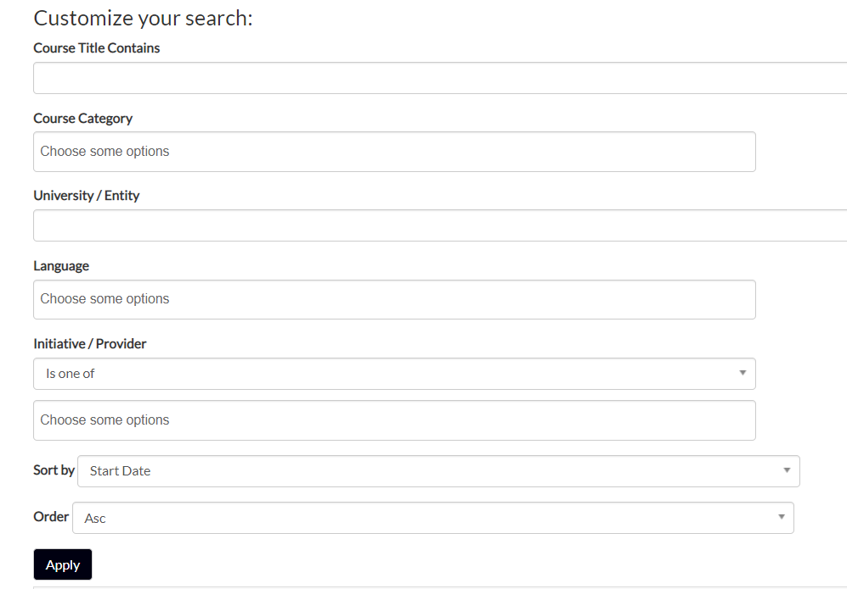
After you have evaluated the OER or MOOC you will need to write a 2-4-page reflection explaining two strengths and two areas for improvement for the reviewed course. You will need to support your claims with at least 4 current (within 5 years), peer-reviewed scholarly references.

To download the Quality Scorecard for your own use follow the steps below:

**Please understand there will be an OLC Quality Scorecard in the assignment template for you to complete. These instructions are for if you want to download the original. **

- Go to the OLC Quality Scorecard Link within this Module
- Click where it says, “Download PDF” under the QCTIP: Course Fundamentals 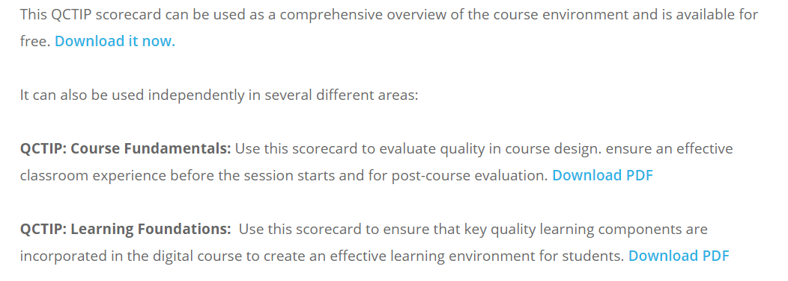
- Fill out the necessary information and click download scorecard.
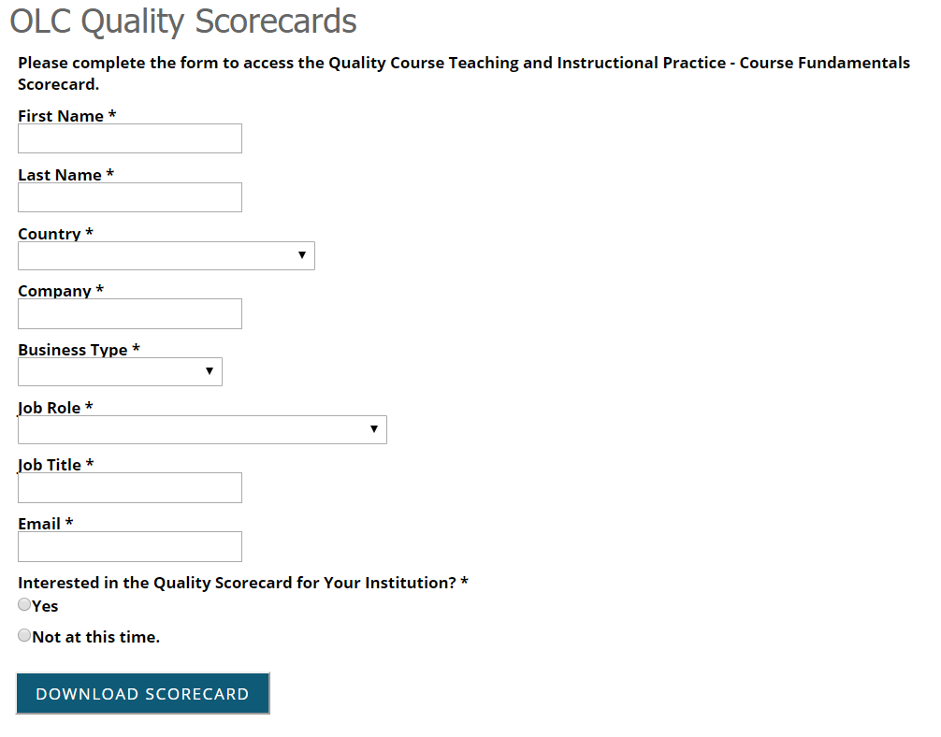

You must use the Evaluating Digital Content Template for this assignment.

